1. Login to ICM1 AW from the remote desktop Connection tool.

Verify the AW sheet before you login to ICM1, 2 or 3 servers.

After logging in to the server to verify if we are in the correct instance click on the configuration manager tool shown below.

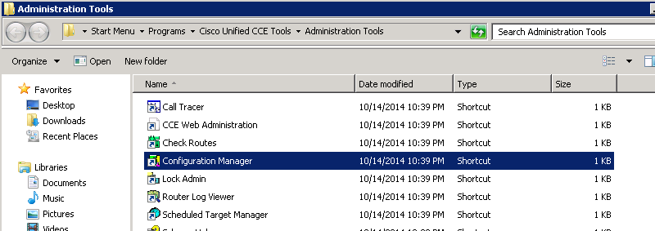

1. After selecting the tool we find different tools under the config. Manager application.

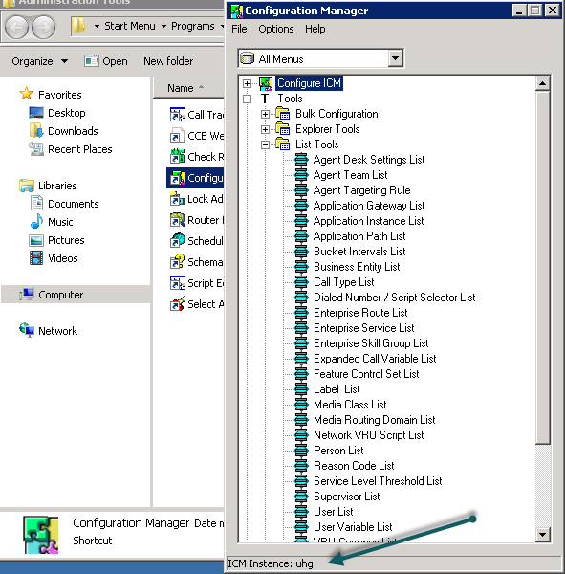

At the bottom of the page we need to verify the instance name as uhg(if we are logged in to ICM1 server and ICM instance.

1. For ICM2 server follow the below steps as followed for ICM and check if the ICM instance is **uhga1**.

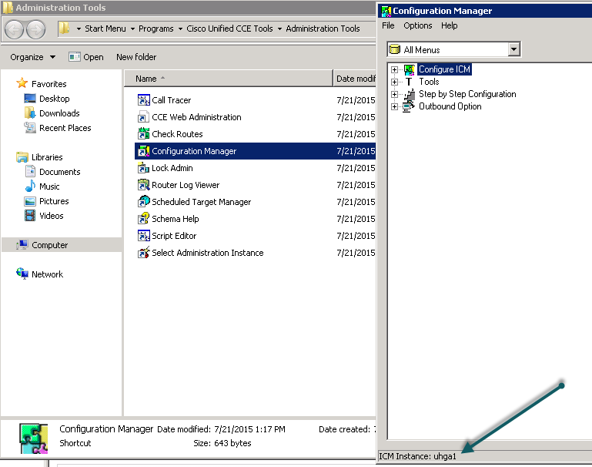

1. Similarly for ICM3 verify the instance is **uhga2**

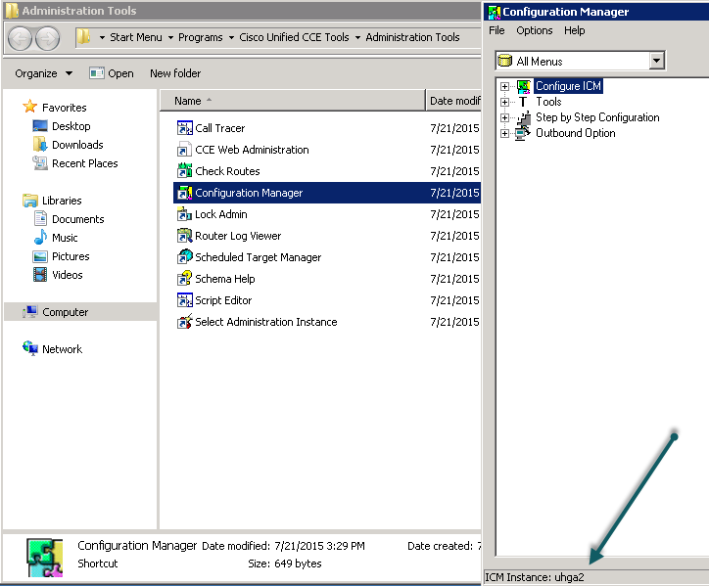

**Note:** When working on any tool/application like ICM scripting or tools check if the Instance displays the respective ICM instance at the bottom of the page.